Q1 . What is the difference between cat and more command?

A1. Cat : read content inside the file

More : read content inside the file based on the screen size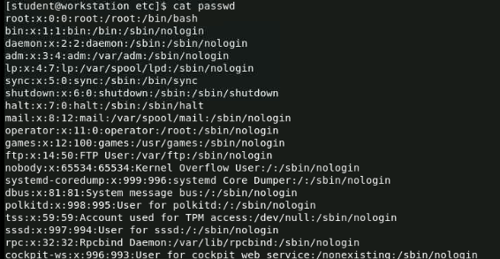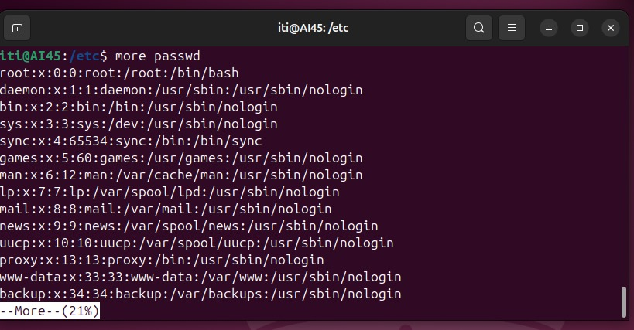

Q2. What is the difference between rm and rmdir using man?

A2. rm : removes files

rmdir : removes empty directory(folder)

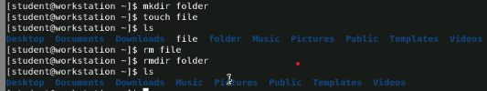

4. Create the following hierarchy under your home directory:

dir1 docs

dir11 dir12 mycv

file1

1. Remove dir11 in one-step. What did you notice? And how did you overcome that?

Answer: rm –r dir11 , because it has content inside.



1. Then remove dir12 using rmdir –p command. State what happened to the hierarchy (Note: you are in your home directory).

Answer : rmdir –p dir1/dir12 , the dir12 and its parent dir1 are removed .



c. The output of the command pwd was /home/user. Write the absolute and relative path for the file mycv

Answer : absolute : /home/student/docs/mycv

Relative : .docs/mycv

5. Copy the /etc/passwd file to your home directory making its name is mypasswd.

Answer : cp /etc/passwd mypasswd



6. Rename this new file to be newpasswd.

Answer : mv mypasswd newpasswd



7. You are in /usr/bin, list four ways to go to your home directory

Answer : cd , c .. , cd~ , cd /home/myusername

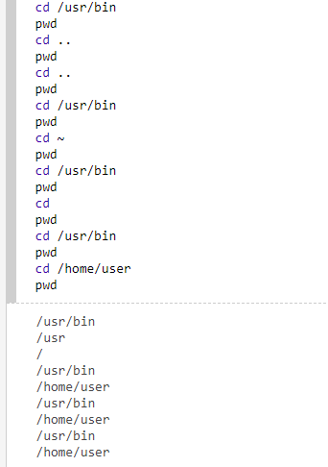

8. List Linux commands in /usr/bin that start with letter w

Answer : ls-l \*w

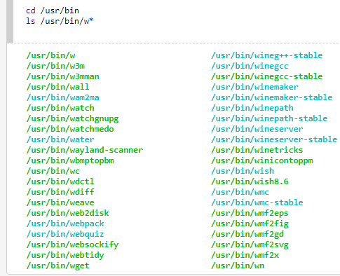

9. Display the first 4 lines of /etc/passwd

Answer : head -4 passwd

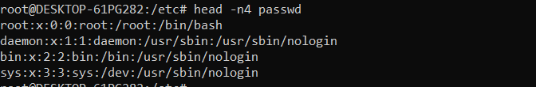

10. Display the last 7 lines of /etc/passwd

Answer : tail -7 passwd

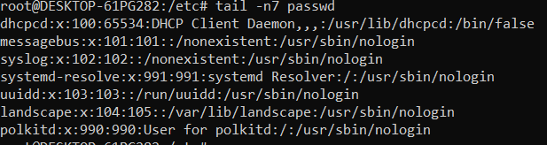

11. Display the man pages of passwd the command and the file sequentially in one command.

Answer : man –a passwd

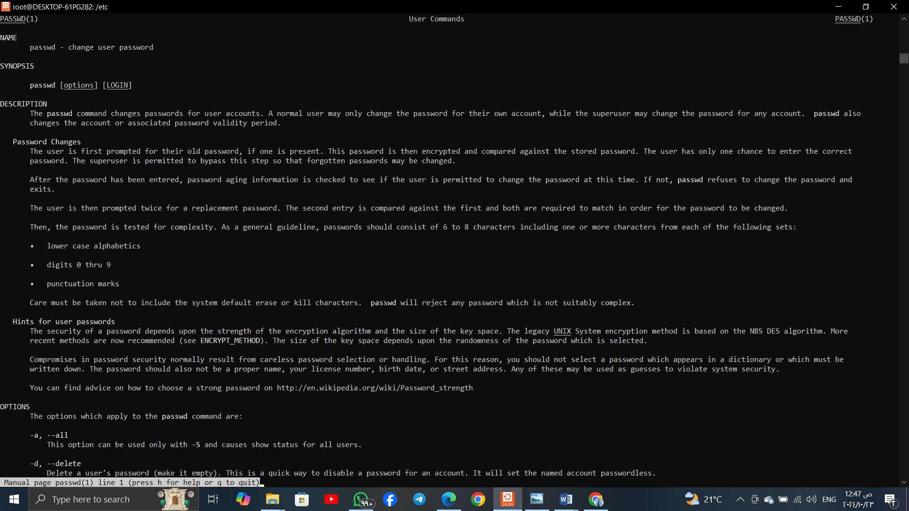

12. Display the man page of the passwd file.

Answer : man 5 passwd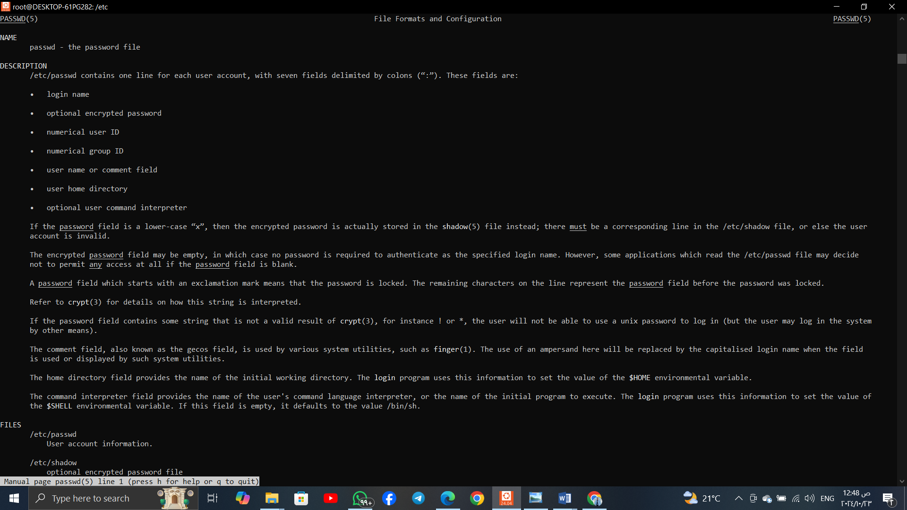

13. Display a list of all the commands that contain the keyword passwd in their man page.

Answer : man –k passwd

